Respondent characteristics

Please indicate which of the following best characterises the organisation you represent:

1. Please indicate which of the following best characterises the organisation you represent:
Pharmaceutical or biotechnology company with own R&D activity
Pharmaceutical or biotechnology company without any own R&D activity
Academic institution or research institute
National professional association for the pharmaceutical or biotechnology industry
European professional association for the pharmaceutical or biotechnology industry
Other (please specify)

*2. Please provide the name of your organisation

3. How many employees does your organisation have (in full time equivalents)?
More than 500
Between 251 and 500
Between 51 and 250
Between 10 and 50
Fewer than 10

4. Is your organisation currently listed on the EMA SME Register?
Yes
No

5. Is your organisation currently, or has it ever been, a sponsor for any EU designated orphan medicinal product?
Yes
No

6. For how many products (not limited to EU designated orphan medicinal products) has your organisation obtained a European marketing authorisation?
None
Between 1 and 3
Between 4 and 10
More than 10

R&D activities: General

*7. Does your organisation currently conduct any R&D activities to support development of medicinal products?
Yes
No

R&D activities: Development of medicines for rare diseases

8. In what therapeutic area(s) has your organisation ever conducted R&D which could result in an application for an EU orphan designation, irrespective of whether these activities have been discontinued or whether marketing authorisation for a product has been obtained?
Alimentary tract and metabolism (A)
Blood and blood forming organs (B)
Cardiovascular system (C)
Dermatologicals (D)
Genito-urinary system and sex hormones (G)
Systemic hormonal preparations, excluding sex hormones and insulins (H)
Anti-infectives for systemic use (J)
Antineoplastic and immunomodulating agents (L)
Musculo-skeletal system (M)
Nervous system (N)
Antiparasitic products, insecticides and repellents (P)
Respiratory system (R)
Sensory organs (S)
Various (V)
None

*9. What are/were the main reasons for your organisation to be active in these particular therapeutic areas? (Please provide max. 3 answers).
Building on existing R&D programmes and/or scientific expertise in these areas
Asset with properties potentially applicable in other diseases or indications
Obtainment of an R&D portfolio (e.g. through acquisition, merger or in-licensing)
Strong scientific, regulatory and commercial expertise in this area
Availability of scientific leads for further R&D
Addressing areas of greatest unmet need
Expectation of being first on the market
Personal commitment of company leadership (e.g. due to family members suffering from a particular disease)
Do not know
Please, provide a brief explanation.

*10. What are/were the main reasons for your organisation to not be active in development of orphan medicines in other therapeutic areas? (Please provide max. 3 answers).
Insufficient fit with overall company focus and R&D pipeline
Lack of scientific expertise in these areas
Lack of scientific leads for further R&D in these areas
Lack of research and/or production facilities to support R&D in these areas
Expectation of insufficient access to patients at a commercially viable price
Insufficient ability to generate data to support marketing authorisation
Do not know
Please, provide a brief explanation

11. Does your organisation have, or has had, more than one research programme within the same therapeutic area focused on product development for treatment of a rare disease?
Yes
No
Not applicable

R&D: Development of EU designated orphan medicinal products

12. Please indicate for how many products your organisation has ever...
Note: Products that received more than one EU orphan designation should be counted only once here.
Applied for EU orphan designation
Received EU orphan designation (i.e. application granted)
Withdrawn EU orphan designation prior to marketing authorisation
Received EU marketing authorisation with confirmation of orphan designation
Received EU marketing authorisation but was denied confirmation of orphan designation

13. How many EU designated orphan medicines does your organisation currently have where development is ongoing and for which no marketing authorisation has yet been granted?
Note: please, provide the number as reported on the sponsor’s annual report on a designated orphan medicinal product to the EMA.

14. For how many EU designated orphan medicines has your company discontinued development?

15. What was/were the main reason(s) for discontinuing development of EU designated orphan medicines?
Lack of efficacy data
Safety issues identified
Change in R&D priorities
Another organisation obtained orphan market exclusivity for a product with a similar EU orphan designation
Insufficient expectations of significant benefit over existing treatment options (pharmacological or non-pharmacological)
Existence of other medicines that are already being used for the target indication (e.g. through off-label usage)
Costs and/or complexities of clinical trials (e.g. difficulty of finding sufficient trial participants)
Not applicable (no development discontinued)
Other (please specify)

R&D: paediatric medicines

*16. Has your organisation ever developed any EU designated orphan medicines that were intended primarily for use in paediatric patients, regardless of whether these medicines obtained marketing authorisation?
Yes
No
Do not know

*17. What were the main reasons to engage in development of EU designated orphan medicines for treatment of primarily paediatric patients? (Multiple answers possible).
Alignment with other own R&D activities
Addressing areas of greatest unmet need
Experience and expertise with development of paediatric medicines
Product already under development with likely significant benefit in paediatric populations
Other (please specify)

Impact of the EU Orphan Regulation on innovator organisations

18. What do you consider the biggest barriers to the development of medicines for treatment of rare diseases?
Potential low return on investment
Financing
Scientific
Regulatory
Other (please specify)

19. Please indicate the general importance of each of the incentives offered under the EU Orphan Regulation to your organisation for overcoming the aforementioned barriers, on a scale of 1 to 4. (with 1 = not important at all, 4 = highly important. If this incentive is not applicable to your organisation, please indicate 0).

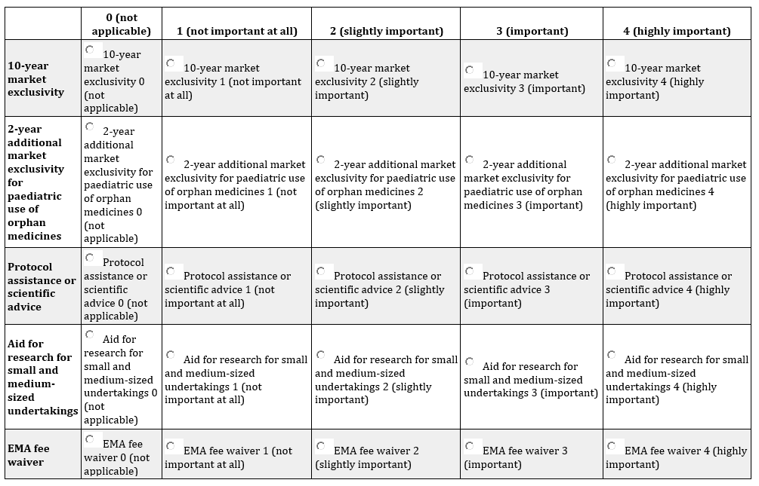

20. Please indicate in which of the following ways the EU Orphan Regulation has influenced your organisation’s R&D activities. (Multiple answers possible).
Increased overall R&D investment
Creation of scientific/therapeutic expertise
Expanded the product pipeline of medicines for treatment of rare diseases
Reallocated resources to new therapeutic areas or conditions with focus on rare disease
Reallocated R&D activities to other jurisdictions (e.g. from US to Europe)
Increased interactions with other organisations active in R&D for rare diseases
None
Do not know
Other (please specify)

21. Please, provide a brief explanation of your answer above.

*22. In which of the following ways, if any, has the EU Orphan Regulation influenced your organisation? (Max. 3 answers).
Increased ability to attract investors
Increased the company value
Increased interactions with patient organizations to inform and improve drug development
Contributed to development of new business models
Increased engagement with patients and/or new methods for patient engagement
Increased incentive to invest in repurposing existing treatments for orphan indications
Increased expertise in new R&D techniques and technologies
None
Do not know
Other (please specify)

23. Please, provide a brief explanation of your answer above.

*24. What challenges, if any, has the EU Orphan Regulation created for your organisation? (Max. 3 answers).
Increased competition from other organisations in therapeutic areas in which the organisation was already active prior to introduction of the EU Orphan Regulation
Increased competition from other organisations in therapeutic areas where the organisation became active after introduction of the EU Orphan Regulation
Increased administrative burden
Increased development timelines resulting from regulatory processes for orphan designation
Do not know / Not applicable
None
Other (please specify)

25. What additional measures would be needed to further incentivise R&D of orphan medicines?
Other financial incentives (e.g. R&D tax breaks, R&D grants)
Clarity on market access criteria
Agreed evidence standards to support access (e.g. conditional approval, accelerated access)
Support for patient registries and post-market data collection and surveillance
Other (please specify)

26. Please, briefly explain your answer below

Role of orphan designation and market exclusivity on competition

27. Has the fact, or likelihood, of another organisation obtaining an initial EU orphan designation (i.e. prior to marketing authorisation) in the EU for their product ever influenced your organisation’s decision to initiate or continue R&D for a product covering the same indication(s)?
Yes: No new R&D was initiated for this specific indication
Yes: Ongoing R&D in this area was delayed or stopped
Yes: Ongoing R&D in this area was refocused
No: Ongoing R&D was unaffected
Not applicable
Do not know
Please, provide a brief explanation.

28. Has the fact, or likelihood, of another organisation obtaining marketing authorisation for an EU designated orphan medicine, resulting in granting of the orphan market exclusivity, ever influenced your organisation’s decision to initiate or continue R&D for a product covering the same indication(s)?
Yes: No new R&D was initiated for this specific indication
Yes: Ongoing R&D in this area was delayed or stopped
Yes: Ongoing R&D in this area was refocused
No: Ongoing R&D was unaffected
Not applicable
Do not know
Please, provide a brief explanation.

R&D investments

29. Please estimate the average annual R&D expenditure (rounded to the nearest € million) of your organisation over the past five years (all products or conditions at any stage of development, including basic research). If you have no reliable information on this or prefer not to say, you may leave blank. You may clarify your answer and/or indicate how these estimates were determined.

30. Please estimate the average annual R&D expenditure (rounded to the nearest € million) of your organisation over the past five years, on products which had potential application for the treatment of rare diseases (at any stage of development, including basic research),irrespective of whether they received marketing authorisation or not. If you have no reliable information on this or prefer not to say, you may leave blank. You may clarify your answer and/or indicate how these estimates were determined.

31. Please estimate the total average R&D costs per product of your organisation on EU designated orphan medicines that obtained marketing authorisation on the legal basis of Article 8(3) of Directive 2001/83/EC, in each of the following R&D stages. If you have no reliable information on this or prefer not to say, you may leave blank. If no R&D is performed in a particular stage, please indicate the amount “€ 0 million”.
Basic research: (€ __ million)
Preclinical R&D phases: (€ __ million)
Combined clinical phases: (€ __ million)
Not applicable

32. If your organisation has successfully developed both orphan and non-orphan medicines, which of the following best describes the average R&D investments per product that were made for these? If you have no reliable information on this or prefer not to say, you may leave blank.
R&D costs for orphan medicines exceed those for non-orphan medicines by a factor of 2 or more
R&D costs for orphan medicines exceed those for non-orphan medicines by a factor of less than 2
R&D costs for both types of medicines are comparable
R&D costs for orphan medicines are lower than those for non-orphan medicines by a factor of 2 or more
R&D costs for orphan medicines are lower than those for non-orphan medicines by a factor of less than 2
Do not know
Please, provide a brief explanation.

33. If your organisation has obtained any marketing authorisations for a EU designated orphan medicine for a well-known compound (through a well-established medicinal use or hybrid application), please estimate the average costs that were associated with preparing the data dossier to support these applications.
Do not know
Not applicable (no such marketing authorisation)
€ __ million

34. Please, provide a brief explanation of your answer above.

35. If your organisation has developed any orphan medicines with more than one EU orphan designation (which was confirmed upon authorisation), please estimate the average additional R&D costs for subsequent authorised indications.
Do not know
Not applicable (no authorised product with multiple EU orphan designations)
€ __ million

36. Please, provide a brief explanation of your answer above.

*37. Has your organisation ever developed a product for which it was required to demonstrate clinical superiority over another product with an EU orphan designation that was under active orphan market exclusivity? If 'Yes', please estimate the additional costs of development associated with demonstrating clinical superiority.
Do not know
No
Not applicable
Yes, (€ ___ million).

Market presence and access

38. Please rate the main market factors that influence your organisation’s decision if, and when to bring authorised orphan medicines to market in particular EU countries on a scale of 1 to 4 (1 = not important at all, 4 = extremely important).
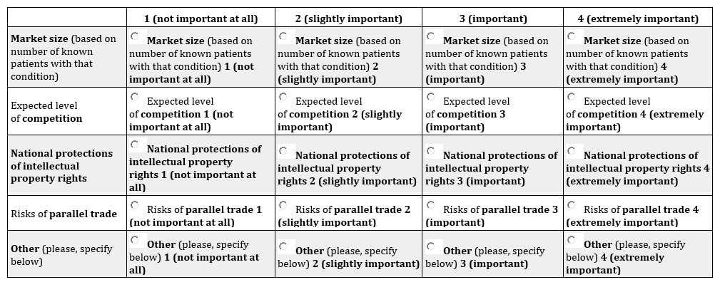If you chose "Other" (please specify in the box below)
39. Please, provide a brief explanation of your answer above.

40. Please rate the main national healthcare system factors that influence your organisation’s decision if, and when to bring authorised orphan medicines to market in particular EU countries on a scale of 1 to 4 (1 = not important at all, 4 = extremely important).
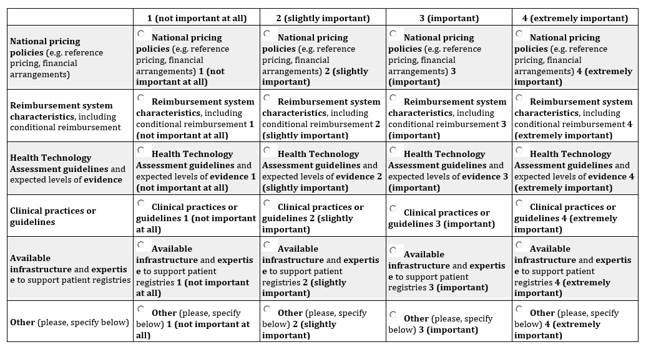If you chose "Other", please specify in the box below.

41. Please, provide a brief explanation of your answer above.

Efficiency and effectiveness of EMA procedures

42. How clear are the criteria for application for the initial orphan designation for applicants?
Very poor
Poor
Acceptable
Good
Very good
No opinion
Please, provide a brief explanation.
43. How predictable are the outcomes of the application process for orphan designation?
Very poor
Poor
Acceptable
Good
Very good
No opinion
Please, provide a brief explanation.

44. How transparent are the application processes for orphan designation?
Very poor
Poor
Acceptable
Good
Very good
No opinion
Please, provide a brief explanation.

*45. Has your organisation ever received scientific advice and/or protocol assistance from EMA for the development of orphan medicines?
No, never
Do not know
Yes, please specify how many times in total

46. Please rate the efficiency of the EMA procedures for initial application and confirmation to maintain EU orphan designation on each of the following dimensions.
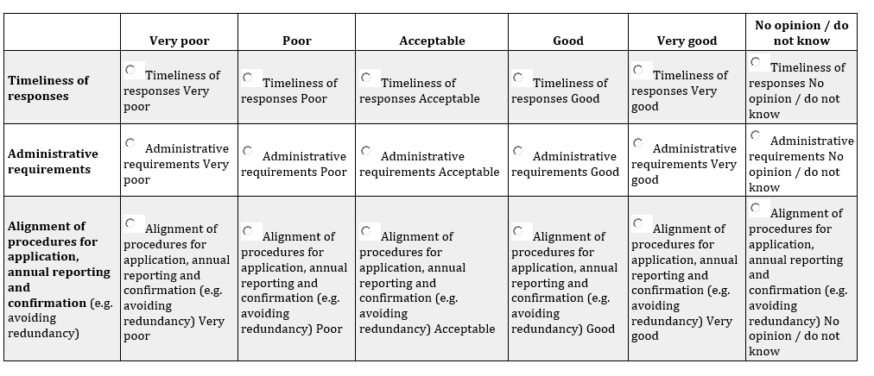Please, provide a brief explanation.
47. How would you rate the appropriateness of the evidence requested by EMA, in terms of the quantity and type of information required, to support the initial application for an orphan designation?
Very poor
Poor
Acceptable
Good
Very good
No opinion / do not know
Please provide a brief explanation.
48. How would you rate the appropriateness of the standard of evidence, in terms of the quantity and type of information required, to confirm the orphan designation at the time of marketing authorisation?
Very poor
Poor
Acceptable
Good
Very good
No opinion / do not know
Please provide a brief explanation.
49. How would you rate the coordination between the different EMA committees (i.e. COMP, PDCO (for paediatric investigations), CHMP (for all marketing authorisations), CAT (for advanced therapies)) involved in the assessment of EU designated orphan medicines of your organisation on each of the following dimensions?
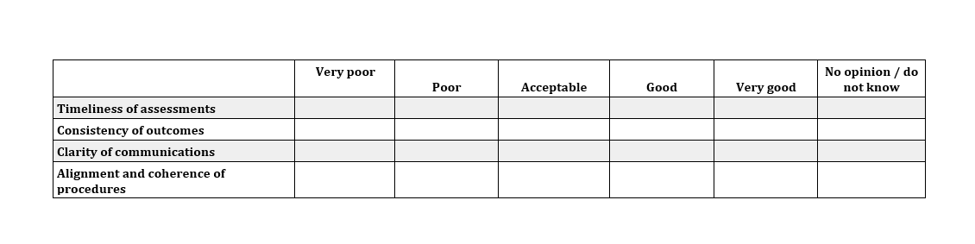Please, provide a brief explanation.

End of the survey!

50. If you have any relevant documentation you wish to share to further clarify your responses, please upload this here or send it to the email address orphan-regulation@technopolis-group.com.
Choose File
No file chosen

51. If you have any further comments about the EU Orphan Regulation, please leave them in the box below.

52. We may want to follow up on some of the survey responses to elaborate further. Please provide your contact details below if we may contact you regarding this study.
Name
Email Address
Thank you for completing the survey!

