11 March 2019
EMA/INS/GMP/710065/2017
European Medicines Agency
Draft How to use the Theft of Medicinal Product Report to report a case of theft to European Medicines Agency

Table of contents
Theft of Medicinal Product Report 3
1. Reporter Details 3
2. Product Details 4
3. Investigation and actions details 4
4. List of Abbreviations 5

Theft of Medicinal Product Report
Download the Theft of Medicinal Product Report template (TMPR) from the European Medicines Agency (EMA) external website.

It is the responsibility of the reporter to ensure that the information provided is accurate and complete.

Mandatory fields must be completed in order to save and send the TMPR. Any uncompleted mandatory field will appear marked in red.

The TMPR temple is divided into three parts:

- Reporter Details
- Product Details
- Investigation and Actions Details

What follows is the description of the main features present in the new EMA report. Most of the fields are self-explanatory. If there are any data fields that are not clear do not hesitate to contact us at qdefect@ema.europa.eu

- Reporter Details
This section captures details of the reporter.
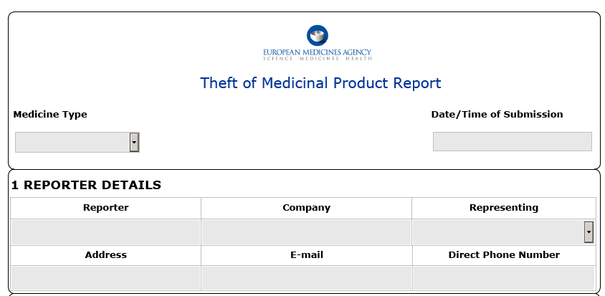

1.1 Reporter name, Company name, email address, address and direct phone number are all self-explanatory.

1.2 Date/Time of Submission: this field is automatically completed on clicking “Submit Notification”. The e-mail address (qdefects@ema.europa.eu) will automatically be inserted on the address bar of your e-mail.

1.3 Medicine Type: choose the correct selection from the dropdown menu (Human/Veterinary/both).

1.4 Representing: choose the correct selection from the dropdown menu:
- Manufacturer
- MAH (Marketing Authorisation Holder)
- Parallel Distributor/ Parallel importer
- Other, please specify
If other, please detail in the related field.

Note: only reports from Parallel Distributors and related to Centrally Authorised Products (CAPs) are sent to the EMA. Reports related to Nationally Authorised Products (NAPs) and Mutual Recognition Procedure/ Decentralised Procedure (MRP/DCP) are required to be sent to the relevant National Competed Authority (NCA).

- Product Details
This section captures the details of the stolen products.
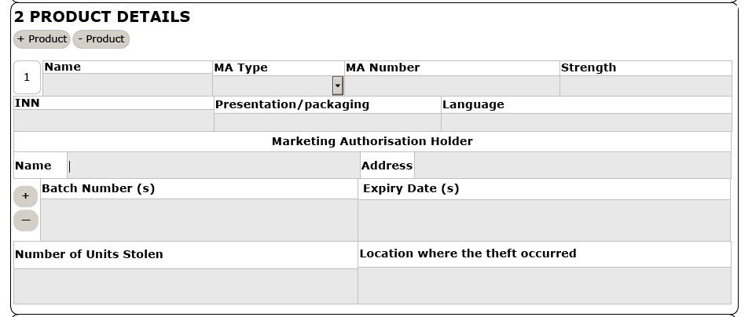

2.1. Some fields in this section are mandatory and self-explanatory.

2.2 The entire part can be duplicated by clicking on “+ Product”. This function duplicates the entire table and allows reporting of additional products involved. A sequential number (e.g. 1,2,3 etc.) is assigned to each product/MA number impacted.

2.3 MA Type: choose the correct selection from the dropdown menu (CAP/NAP/MRP/DCP).

Note: only reports from Parallel Distributors and related to CAPs are sent to the EMA. Reports related to NAPs and MRP/DCPs are required to be sent to the relevant NCA.

2.4 The two fields (3.5, 3.6) can be duplicated by clicking on “+” allowing reporting of additional batch (es) and expiry date identified.

2.5 Batch Number (s): list the batch (es) involved in the theft. This field can be duplicated by clicking on “+”.

2.6 Expiry Date (s): list the expiry date (s) involved in the theft. This field can be duplicated by clicking on “+”.

2.7 Number of units stolen: specify how many units were stolen.

Note: if the theft involved several products the list of medicines can be attached by using the “Attach file” button (see point 3.4).

- Investigation and actions details
This final part captures description of the investigation performed.
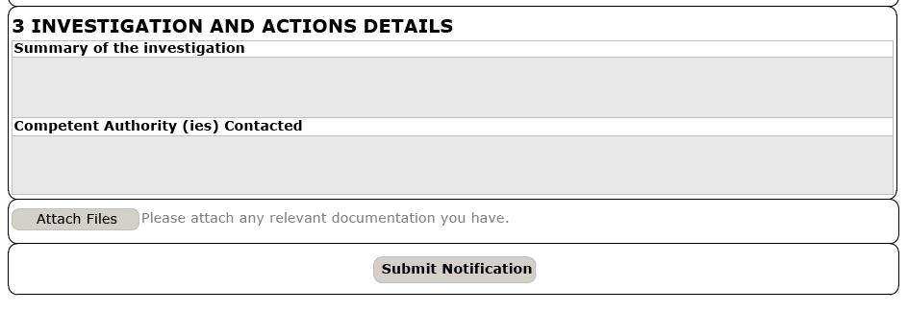

3.1 Some fields are mandatory. Free text boxes allow the reporter extra flexibility.

3.2 Summary of the investigation: describe the investigation performed and the action taken. Provide details of the trades involved, if known.

3.4 Attach Files: attach key documentation such as: confirmatory test report, investigation report and any other relevant document.
Provide a timeline for submission, if any information is outstanding at the time of the reporting.

- List of Abbreviations

CAP: Centrally authorised product
CAPA: Corrective actions preventive action
INN: International non proprietary name
MA: Marketing authorisation
MAH: Marketing authorisation holder
MRP/DCP: mutual recognition procedure/ decentralised procedure
NAP: nationally authorised product

