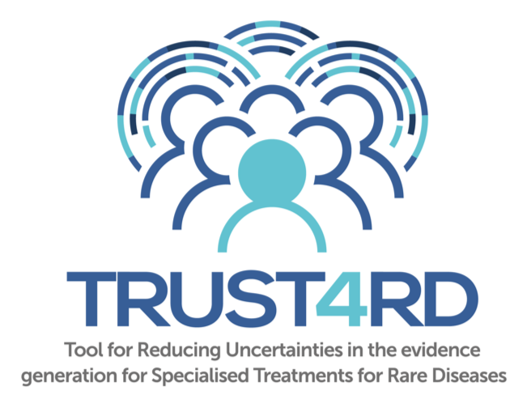
Tool for Reducing Uncertainties in evidence generation for Specialised Treatments for Rare Diseases.
TRUST4RD
March 2019

Acknowledgements
This paper has been commissioned by RIZIV-INAMI and authored by Professor Lieven Annemans (Ghent University), supported by co-author Dr Amr Makady (University of Utrecht). The following individuals and stakeholder representatives from patient groups, healthcare professional organisations, government bodies and industry have participated in a series of roundtable discussions, facilitated and chaired by FIPRA and supported by Efpia, Eucope, EuropaBio and Shire, Sanofi Genyzme, Celgene, BioMarin, Takeda and Actelion:
- Simone Boselli, Public Affairs Director, EURORDIS
- Karen Facey, University of Edinburgh
- Cédric Hermans, Head Haemostasis and Thrombosis Unit/Haemophilia Centre of the Saint-Luc University Hospital, Belgium
- Jane Moseley, Senior Scientific Officer, European Medicines Agency (EMA)
- Luca Sangiorgi, Head of Medical Genetics and Rare Orthopaedic Diseases, Rizzoli Orthopaedic Institute, Italy
- Maurizio Scarpa, Regional Coordinating Centre for Rare Diseases, Udine University Hospital, Italy
- Chris Sotirelis, Patient Advocate, EURORDIS
- Sheela Upadhyaya, Associate Director, Highly Specialised Technologies, National Institute for Health and Care Excellence (NICE)
- Marc Van de Casteele, Pharmaceutical Assessments Coordinator, RIZIV-INAMI
- Inneke Van de Vijver, Managed Entry Agreements Taskforce, RIZIV-INAMI
- Martin van der Graaff, Secretary, Scientific Advisory Board, Zorginstituut Nederland (ZIN)

Introduction and objectives
Many of the treatments developed for rare diseases will have an Orphan Medicinal Product (OMP) designation indicating that they are likely to deliver benefit in an area of high unmet need. Their approval may be based on a small or uncontrolled trial, as randomized controlled trials (RCTs) of sufficient size are often difficult to conduct, or to repeat, as a result of the rarity of the condition, sparsity of patients, or because of ethical reasons. Furthermore, many products are given a conditional marketing authorisation, requiring additional evidence to be collected after product launch. This situation has become even more challenging with the advent of advanced therapeutic medicinal products, which use novel scientific approaches like gene therapy, somatic cell therapy or tissue engineered products administered to human beings with a view to regenerating, repairing or replacing a human tissue.
Given the high unmet need associated with these products, there is pressure for Health Technology Assessment (HTA)/reimbursement bodies to enable rapid access to effective treatments, which requires spending public money. However, related to the rare and complex nature of the conditions they treat, there is often only limited evidence on these products available for assessment. Uncertainties may occur about the care pathway, natural history, treatments’ clinical outcomes in the longer term, added value to patients and value for money to society.
For industry the investment to develop these specialized treatments is important with limited possibilities for economies of scale, and for society there is a high treatment cost per patient albeit mostly with a rather limited overall budget impact.
As a result of the combination of high prices (albeit for a relatively small number of patients) and uncertainty in evidence, decision makers in healthcare, particularly HTA agencies and healthcare payers find themselves forced to make decisions about reimbursement under difficult conditions.
Guidance is therefore needed that supports discussion amongst all stakeholders to develop an understanding of the potential evidence that could be generated both pre- and post-HTA submission and to allow trade-offs in different approaches to evidence generation vs the societal issues of access to these medicines and wise use of limited healthcare resources.
This paper aims to develop a technical but pragmatic tool and methodology that allows the uncertainties in evidence for a specialised treatment for a rare disease to be made explicit, to be prioritized and to be addressed in an adequate and timely way. Additionally, the paper provides guidance on the potential of real-world evidence (i.e. data collected outside the context of randomised controlled clinical trials; RWE) to help address such uncertainties.
It builds on existing initiatives from the European Commission and the European Medicines Agency (EMA), the Innovative Medicines Initiative (IMI) , EUnetHTA, MoCA (Mechanism of Coordinated Access to OMPs), ISPOR, ORPH-VAL, and in papers by Annemans and Pani, Hampson at al., Mitroiu et al. and the EMA post authorisation efficacy study guidance. This paper aims to translate the findings and recommendations from these initiatives into a pragmatic and realistic methodology. The proposed tool will provide guidance to inform multi-stakeholder discussions and reimbursement decision making about specialized treatments for rare diseases. It is aspirational but builds on the emerging experience of the value of multi-stakeholder dialogues by proposing a structure that explicitly names and addresses uncertainties that are common in specialised treatments for rare diseases.

Methods
Commissioned by the Belgian Institut National d'Assurance Maladie-lnvalidité/ Rijksinstituut voor ziekte- en invaliditeitsverzekering (INAMI/RIZIV), the paper was developed through multi-stakeholder dialogue. Stakeholder representatives from patient groups, healthcare professional organisations, government bodies (including payers and HTA authorities) and the pharmaceutical industry participated in a series of roundtable discussions to contribute to the paper and a workshop to pilot a template aimed at supporting dialogue. In addition, a drafting committee comprised of a smaller group of similar stakeholder representatives also supported the writing of this paper.

Explaining the tool
As stated in the introduction, uncertainties exist in the evidence base submitted to HTA for specialised treatments for a rare disease. Uncertainties will of course always exist and may also evolve over time. Typically, some uncertainties may be unavoidable at an early stage but may be addressed later on. This paper proposes an approach to identify the uncertainties that are of most concern for decision makers. It sets out a way to reduce these uncertainties that centres on developing an iterative and informed dialogue amongst stakeholders so that potential approaches to resolve them can be discussed. As evidence is generated, the uncertainties are reviewed and prioritised, so that evidence generation plans can be revised or clarified. The aim is to develop – both pre- and post HTA submission – better understanding of evidence requirements vs evidence generation trade-offs as an evidence base grows and the potential value of a product becomes clearer. Like the advice given in current regulatory and HTA settings (Scientific Advice, Early Dialogues etc), this advice would not be binding on any party.
The method consists of 3 building blocks – evidence gaps; data sources and design; and iterative dialogue – that all evolve over time, as shown in Figure 1. The figure also emphasizes the distinction between the situation pre- and post HTA, which will be clarified further on in the text.

Figure 1: TRUST-4RD building blocks
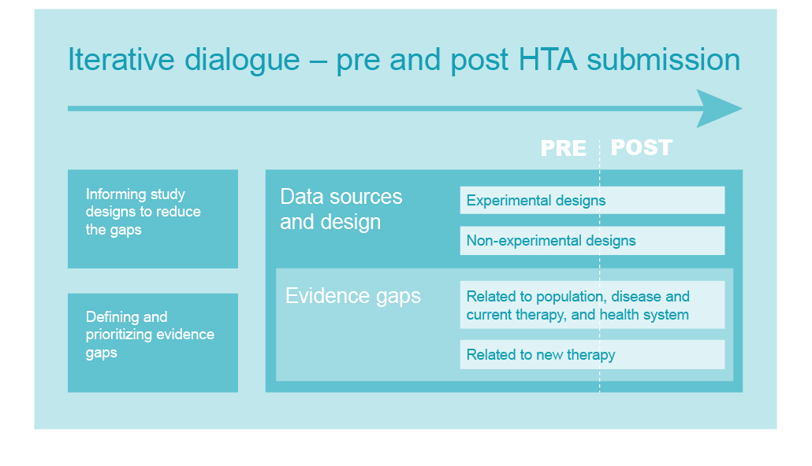
These building blocks are described in detail below. Naturally, they are not isolated ‘single’ streams but are nested within each other as illustrated in the Figure.

3.1 Typology and prioritisation of evidence gaps
We propose a taxonomy whereby we distinguish four main types of evidence gaps/ uncertainties that are common at the time of access decisions for treatments developed for complex or rare diseases:
- Uncertainties related to the size and characteristics of the population
- Uncertainties related to the natural history of the disease and its current management
- Uncertainties related to the new treatment
- Uncertainties related to the health eco-system
We describe these here in more detail, without the ambition to provide an exhaustive list. Obviously, for a given dossier multiple uncertainties will exist at the same time.
The first set of uncertainties are those related to the size and characteristics of the population. We think hereby of uncertainties about:
- the incidence and prevalence of the disease;
- the exact size of the target population (high risk, Xth line treatment, …);
- the characteristics of sub populations and target populations (age, time since diagnosis);
- the spectrum and variations of disease manifestations (mild, moderate, severe symptoms);
- genotyping, phenotyping,…;
- local variations…
The second set of uncertainties is about the natural history of the disease and its current management, such as:
- the typical natural course or history of the disease over time;
- prognosis;
- current standards of care (e.g. what are these standards, are they optimal, …) and relevant comparator (might be best supportive care; might also shift over time);
- the relevant endpoints for clinicians and patients to assess and monitor the disease state;
- the extent of the unmet need, in terms of impact of the disease and the way it is currently managed on quality of life and survival, and the variability herein observed between patients;
- …
The third set of uncertainties is related to the new treatment. We think hereby of uncertainties about:
- the size of the treatment effect (e.g. large confidence interval resulting from the trial);
- optimum posology
- treatment effect with different subgroups
- the size of the effect in the real target population when the trial population is different;
- the relationship between biomarker or short-term outcomes and longer-term clinical endpoints (such as long-term survival);
- in which patients the treatment works best;
- durability of the effect, e.g. the possibility of a waning of effect, or a recurrence, as well as the possibility to retreat after recurrence;
- the way in which the new treatment will modify the treatment sequence and related outcomes;
- the ability of a biomarker to predict a treatment effect;
- adverse events and safety;
- …
Finally, a set of uncertainties is related to the healthcare eco-system and its actors (patients, clinicians, hospitals, …). We distinguish here uncertainties about:
- patient acceptability and compliance (which are obviously also influenced by the medical need, QoL and treatment effect);
- provider prescription patterns and capacity to work with the current and new treatment;
- consequences to the health care system budget (extra costs or cost offsets);
- consequences to society (reduced absenteeism, …);
- diagnostic capabilities;
- alteration of organisation of care;
- …

The tool involves as a first step that the key present and expected data gaps for a given “dossier” are explicitly listed early in the development of the treatment.

Obviously, uncertainties and data gaps evolve over time. They might be explained by a combination of factors related to the nature of the disease, its treatment or the system as well as to the quality of the (planned) evidence generation. At the time of submission for HTA some data gaps will be unavoidable (for instance long term effect on survival); others might be avoidable if the right data are obtained during the development process.

Also, the impact of these uncertainties for a given dossier needs to be addressed early to identify the highest priorities for evidence generation. Indeed, some of the uncertainties may have a much larger impact on the eventual value of the treatment than others. The collection of data that are unlikely to help demonstrate the value of a technology should be avoided and therefore a process of prioritisation is needed.

Multi-stakeholder input at this point is essential as stakeholders’ views may differ and coming to a common understanding of issues will help identify priorities. See the first milestone in the iterative dialogue process further on in the text.
We propose to add an impact score (e.g. +++, ++ or +) to distinguish between uncertainties that matter most versus those that are much less relevant in the ultimate assessment of value and value for money. This score should be informed by both quantitative and qualitative inputs. The quantitative inputs refer to ‘what if scenarios’ (sensitivity analyses) on key final endpoints such as survival and quality adjusted survival, cost-offsets etc… The qualitative inputs involve determining the perspectives of patients and clinicians regarding the importance of the uncertainty.

3.2. Potential sources to generate reliable evidence
Broadly there are eight types of data sources/study designs that may be needed and can be used (if available) to address the uncertainties in a given dossier and generate reliable evidence. The proposed classification is based on 2 criteria.
A first distinction is made between data sources and designs that can generate appropriate data about the size of the population, the disease and its current management, the new therapy or the health eco-system. Typically, prior to or while the evidence generation about the new treatment is undertaken or conducted, data sources and designs can be considered to reduce the evidence gaps regarding population, disease, current management and the health eco-system.
A second distinction is about whether the data are collected in experimental interventional designs, such as randomised comparative trials, including their possible extension, or rather based on observation of routine practice in a non-experimental setting; i.e. real-world data that – if well managed, analysed and reported – will lead to real-world evidence.
Combining the 2 criteria thus leads to different types of data sources/designs, as indicated in Table 1. Note that some parallel can be drawn with the classic PICO approach in evidence based medicine (Patients; Intervention; Comparator; Outcomes).
As explained above, real-world data about the population, disease, current treatment(s), and health eco-system can and should be collected as much as possible during the development phase of the new treatment. At this stage also, experimental data on the current management may possibly exist and be used.
Real-world evidence about the new treatment can obviously only be collected after-market authorisation, with the exception of compassionate use or early access programmes.
Each of these different data sources/designs have inherent pros and cons. The idea is that for each type of important evidence gap, the corresponding data source and design to reduce that gap is proposed, and that the pros and cons of that data source/design for that specific evidence gap are discussed. Ideally, the most adequate data source/design meets the evidence gap.

Table 1: Types of data sources/designs available to anticipate, avoid or solve uncertainties
 | Experimental | Non-experimental
Population size and characteristics | - previously published comparative trials (with focus on baseline characteristics)  - … | - disease and/or population registries,  - claims databases,  - electronic patient records,  - biobanks,  - surveys,  - patient interviews  - …
Disease & current management | - previously published comparative trials  - clinical guidelines  - … | - Idem as above
New  treatment | - RCT vs standard of care  - pragmatic trials  - case series compared with historical controls  - nested randomisation study in a disease or population registry,  - network meta-analysis for indirect treatment comparison  - … | - Idem as above
Health eco-system | - previously published comparative trials (with focus on adherence, absenteeism, resource use)  - … | - Idem as above

3.3. An iterative dialogue and communication line
Reducing uncertainty and increasing understanding between stakeholders requires an iterative communication between a company and the HTA body/payer and regulator for a particular dossier to regularly take stock of newly acquired knowledge and to revise evidence generation commitments that might not be feasible.
Although we want to emphasize the iterative character of this communication that evolves dependent on the needs of each product, three milestones are identified that we consider to be desirable pre-planned points for each treatment, as illustrated in Figure 2 and explained below.
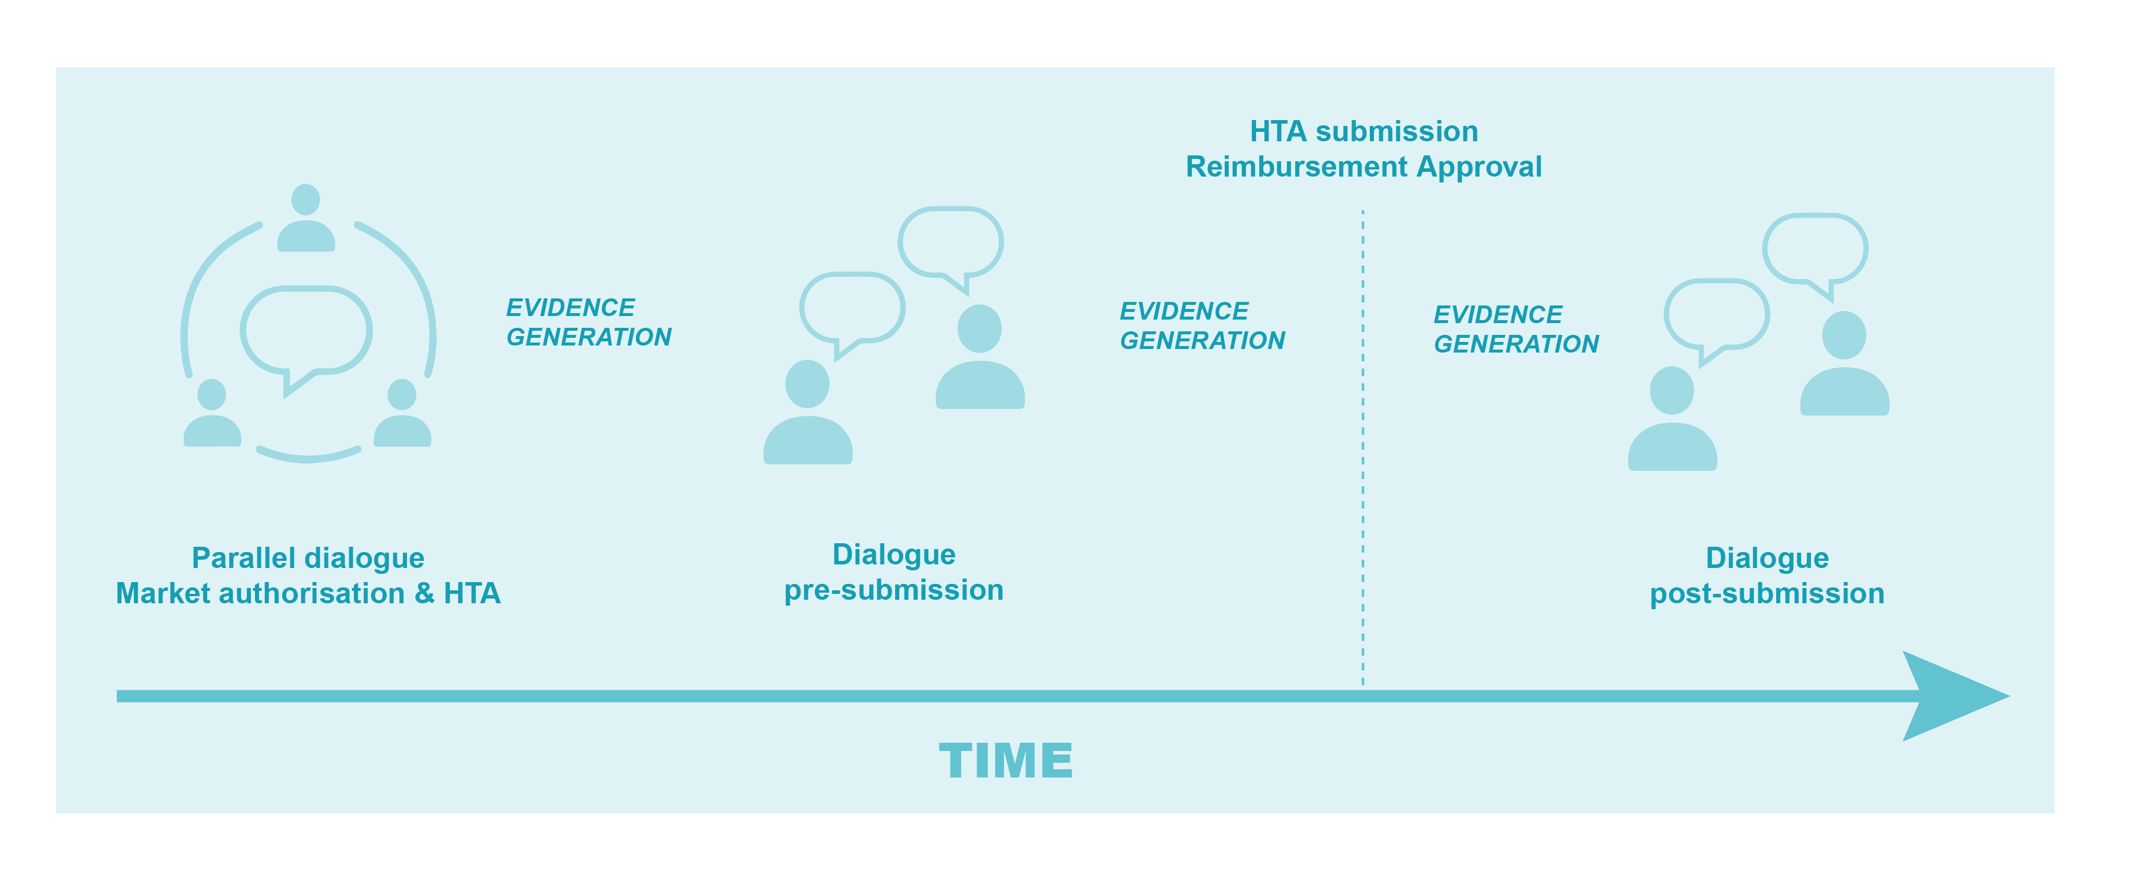
Figure 2: TRUST-4RD iterative dialogue
A first milestone is an early dialogue between industry, regulatory authorities such as EMA and HTA/payers, in the presence of clinicians and patient representatives. HTA/payer representatives from different countries should be involved. The rationale is that uncertainties can be avoided or solved by adjusting the design of pivotal interventional studies at an early stage. We refer here for instance to the work done by IRDIRC on clinical trials with small sample size. It must be made clear therefore as soon as possible in the development process whether for practical or ethical or other reasons a randomized design is an option or not.
Of course, not all uncertainties can be identified and discussed early on. Hence, the early involvement is needed but will not be sufficient to deal with all evidence gaps at that point.
The first dialogue should take place very early in clinical development with all stakeholders to share the scientific ethos behind the development of the treatment, discuss any potential disruptive aspects of the technology in the healthcare system (e.g. form of reimbursement routes), potential evidence uncertainties and the overall plan for evidence generation. More than one dialogue is of course possible during this phase but at least one should be organised. It is obviously also possible to have at this stage bilateral dialogues, i.e. between industry and individual payers, alongside the multi-stakeholder joint dialogue but the focus at this early stage lies on the latter format. The taxonomy of evidence gaps, and the proposed data collection must be on the agenda of this early joint dialogue and possible bilateral dialogues.
In each specific dossier, issues will occur with the available/planned data sources and designs. It is important that these issues are explicitly listed and discussed, leading to suggested solutions. The process for this should be as illustrated in Figure 3.
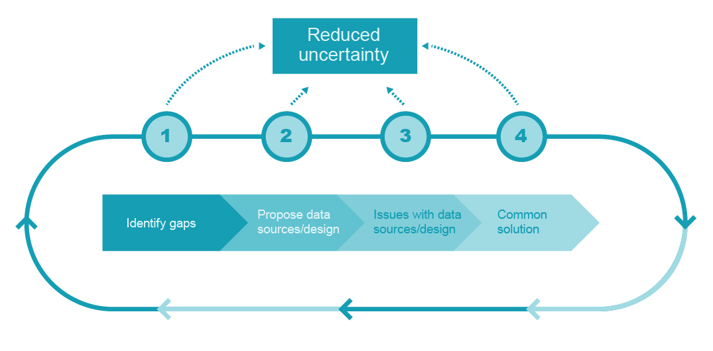
Figure 3: process for matching data sources/designs with evidence gaps
For step 1, the list of possible evidence gaps can be consulted to identify the major gaps. For step 2, the list of available data sources and designs can be consulted. For step 3, the overview of pros and cons of the different data sources can serve as input. Step 4 requires the application of the principled compromise concept. , This concept involves that during the process and the related debates, statements and communications should be:

- Reliable: there should be no over-claiming
- Reflective: critically robust positions should be aired and debated
- Respectful: negotiations should take place in a democratic spirit
The following example shows how this may work during this first early dialogue:
Example: anticipated gap regarding long term evidence of the new treatment. Plan follow up of trial patients. This will lead to more information about the sustainability of the effect, but it will still be based on a trial-population a solution might be to timely plan to include patients treated post launch in routine practice in a – preferably existing – registry and observe real-world long term follow up outcomes.
Additional issues and solutions were raised during an interactive workshop with industry, representatives from HTA bodies, payers, patient associations and clinicians. We propose that an inventory of issues and solutions is created according to the above framework and regularly updated by HTA authorities so that future submissions and negotiations can learn from these and find inspiration in previous solutions. In the Appendix, examples of such issues and solutions are listed.
A second dialogue should ideally take place after the completion of the pivotal trial in order to address remaining uncertainties, with the remaining data gaps explicitly on the agenda. Again, more than one dialogue is possible but at least one should be organized. This dialogue should take place before official submission for HTA and should again involve patients and clinicians. This dialogue may also be bilateral and on a country (or group of countries’) level. Importantly, the potential for post-launch data collection should be discussed here. Indeed, if there is post-launch data collection, this pre-HTA dialogue will already discuss what data should ideally be collected which will facilitate the eventual agreement on post-launch data collection (such an agreement usually takes place after the assessment). The same process as illustrated in Figure 2 is proposed.
The following example shows how this may work during this pre-HTA dialogue:
Example: Uncertainty about the relationship between the effect on a surrogate outcome and the effect on a clinically relevant outcome (e.g. respectively response rate and survival) There has been a ‘historical’ correlation shown between the planned surrogate outcome and the clinically relevant outcome, but that was with current standard of care. However, it is likely that this relationship may not be the same for the new treatment a solution is to accept the historical correlation in the simulations for HTA submission and to explore the new relationship in a registry post launch.
The first and second dialogue are both early dialogues, however with different timings, namely before and after the major confirmatory evidence on the new therapy. There are existing models for scientific advice/early dialogues in EMA and EUnetHTA. These require organisation and resources from all parties involved with development of a Briefing Book of issues by Industry and a response document by EMA/HTA bodies. During the data collection period regular submissions are needed to review quality and quantity of data or amend plans as needed.
A third milestone dialogue is then the post HTA dialogue will discuss the results of the additional evidence generation post-launch and its further consequences. This third milestone is focused on assessing whether the predictions that were made upon the time of HTA submission are validated in the real-world setting. The consequences of ‘not making the promise’ may also be financial if it was decided upon launch to install a risk sharing agreement. We refer to Makady et al (2018) for several examples of therapeutic interventions whereby RWE has positively contributed to addressing uncertainties in the evidence base, leading to better informed decision making.

Necessary conditions
This process can only work if certain conditions are put in place.
It first of all requires investing in data generation. Consideration should be given to an EU fund for real-world data generation and supranational collection of data on rare or complex conditions. The European Reference Networks seem to be the ideal vehicle for this purpose. Also, public private partnerships may be needed to sustain data collection with strong governance rules to define custodianship of and access to data, and to solve issues related to privacy and data integrity. This effort should not be underestimated as it requires investments beyond the building of an infrastructure and consensus on core data elements, endpoints and standardization.
Moreover, success of the tool requires an understanding that to generate evidence for HTA/payers the limitations of data sources and robust analyses are required, but that for some situations the optimal forms of analysis are not yet clear. There needs to be an agreement between the different stakeholders on a specific protocol for data collection but also on the methods used to interpret the results to assess their quality and acceptance by all partners.
Finally, outcomes-based managed entry agreements between industry and payers may be needed, given the level of uncertainty at the time of launch. These schemes can include individual-based or population-based performance linked reimbursement schemes with money pay back guarantee or coverage upon evidence development schemes, whereby the later reassessment leads to an adaptation of the reimbursement conditions. To this effect, we refer to the document on Dynamic outcomes based approaches to pricing and reimbursement of innovative medicines (Annemans & Pani, February 2017), but recognise that there remain concerns – such as administrative burden – about the feasibility of administering these schemes. It is obvious that more investing in better health information systems that reduce administrative burden and improve health data quality is needed.
This tool should lead to more win-win solutions for all stakeholders involved i.e. allowing payers and policymakers to control expenditure and improve the life of patients, industry to reduce the time lag between marketing authorisation and access to treatment while generating real-world evidence, and patients to have earlier and appropriate access to new treatments.

Discussion
This paper presents guidance on defining uncertainties and evidence gaps in the assessment of value and value for money of specialised treatments for rare diseases. Additionally, the paper provides guidance on the potential of real-world evidence to help address such uncertainties. In brief, the guidance addresses the following aspects: the typology of evidence uncertainties, the importance of different uncertainties and the (real-world) evidence sources available to address such uncertainties either before or after HTA submission. Importantly, this guidance is the result of multi-stakeholder, multi-round discussions thus combines the different perspectives of stakeholders involved in discussions and decision making on specialised treatments for rare diseases.
A number of the recommendations made within this guidance correlate well to work within ongoing initiatives. For example, the authors recommend early dialogue between manufacturers, regulatory authorities and HTA agencies on the nature of (real-world) evidence to be collected. Presently, work package 5a (WP5a) of the European network of HTA (EUnetHTA) is specifically addressing this issue. Moreover, the authors advise to continue dialogue in the post-launch setting. Work package 5b (WP5b) of EUnetHTA is addressing the issue of joint post-launch evidence generation (e.g. through patient registries) for HTA purposes. In fact, 2 pilot projects are ongoing within WP5b, of which one on a highly specialized treatment.
In the previous section, we briefly refer to additional conditions necessary for advancing the generation of robust (real-world) evidence, including structural EU-wide collaboration on data collection, standardization of databases and data governance. We have also previously mentioned the suitability of the ERN as a vehicle for this. Another important initiative aiming to address similar issues is the Innovative Medicines Initiative (IMI-) European Health Data Network (EHDN). Over the next few years, the IMI-EHDN will strive to provide a harmonized data infrastructure model and pragmatic governance framework to accommodate cross-centre, cross-country analyses. The outputs of such initiatives are critical to successful implementation of the guidance presented in this article. The principles put forward in the EMA adaptive pathways project (aiming to facilitate best use of existing tools through multi-stakeholder dialogue, including patients), the IMI-ADAPT SMART approach and the New Drug Paradigms (NEWDIGS) also show the important advances already made on this topic.

Clearly, iterative discussions between stakeholders and continuous evidence generation support informed rational evidence generation.
In conclusion we encourage all stakeholders including manufacturers, clinicians, patients, regulatory- and HTA agencies and payers to make use of the guidance provided in this article as they proceed in developing evidence generation pathways on specialized treatments for complex or rare conditions. It is our hope that in doing so, authorization and reimbursement discussions on such treatments can be embedded in an evidence-rich context, thereby ensuring value to all parties, particularly to patients.

Appendix: examples of ISSUES and SOLUTIONS
Pre- confirmatory trial
No comparative evidence yet on the new therapy Proposal for conducting an RCT. Randomisation is not possible (argumentation needs to be offered) a solution might be to design a single arm study and compare the results with matched historical controls.
It is anticipated that there will be no long term data about the new therapy. Proposal for collecting data on an intermediate endpoint. there is no good evidence on the relationship between the intermediate endpoint and the long term clinically relevant endpoint a solution might be to undertake parallel research on the disease and its current therapy to better understand the relationship between intermediate endpoint(s)/biomarkers and clinical endpoint
There is an anticipated gap regarding long term evidence of the new treatment. Proposal to plan follow up of trial patients. This will lead to more information about the sustainability of the effect, but it will still be based on a trial-population a solution might be to timely plan to include patients treated post launch in routine practice in a – preferably existing – registry and observe real-world long term follow up outcomes.
the unmet need in terms of quality of life of patients is unclear. Proposal to collect baseline data on QoL in the trial. there is concern about patient selection for the trial a solution might be to assess QoL in all patients per centre, whether or not participating in the trial
for ethical reasons a traditional RCT is not possible. A ‘delayed start’ or cross-over design is proposed; this means that at the end of the trial, all patients will be treated with the new treatment. a solution might be to compare outcomes of the ‘early starters’ and the ‘delayed starters’ with a matched historical cohort.
Pre-HTA, after confirmatory trial
By the time of submission, there will still be uncertainty about the relationship between the effect on a surrogate outcome and the effect on a clinically relevant outcome (e.g. respectively response rate and survival) There has been a ‘historical’ correlation shown between the planned surrogate outcome and the clinically relevant outcome, but that was with current standard of care. However, it is likely that this relationship may not be the same for the new treatment a solution is to accept the historical correlation in the simulations for HTA submission and to explore the new relationship in a registry post launch.
By the time of submission, the number of expected recurrences is uncertain but anticipated to be very low. it was proposed to follow up recurrences further on in the trial the sample size of the trial is too small for this purpose a solution might be to apply an existing claims database allowing to follow up all patients in real life. This could be combined with an outcomes guarantee contract.

The views expressed in this article are the personal views of the EMA contributor and may not be understood or quoted as being made on behalf of or reflecting the position of the Agency; furthermore, no costs or expenses of the contributor were borne by industry in contributing to this article.
https://ec.europa.eu/health//sites/health/files/files/eudralex/vol-1/reg_2007_1394/reg_2007_1394_en.pdf
Davis C, Naci H, Gurpinar E, Poplavska E, Pinto A, Aggarwal A. Availability of evidence of benefits on overall survival and quality of life of cancer drugs approved by European Medicines Agency: retrospective cohort study of drug approvals 2009-2013. British Medical Journal 2017;359:j4530
The EMA has launched PRIME, Adaptive Pathways, Guidance on the Scientific application of conditional marketing authorisation for medicinal products, Scientific guidance on post-authorisation efficacy studies; Davis C, Lexchin J, Jefferson T, Gotzsche P, McKee M. Adaptive pathways to drug authorisation: adapting to industry? British Medical Journal 2016;354:doi 10.1136/bmj.i4437; Eichler HG, Hurts H, Broich K, Rasi G. Drug regulation and pricing: can regulators influence affordability? The New England Journal of Medicine 2016;374 (19): 1807-1809;
GetReal - Analyses how RWE can supplement RCT in the decision-making process of HTA assessments; ADAPT SMART - Accelerated Development of Appropriate Patient Therapies: a Sustainable Multi-stakeholder Approach from Research to Treatment Outcomes initiative
Mechanism of Coordinated Access to Orphan Medicinal Products. https://www.eurordis.org/content/moca. Accessed 20 October 2018.
ISPOR-ISPE taskforce has published recommendations on Real World Evidence in Health Care Decision Making, enhancing the Transparency and Credibility (Berger et al., 2017b)
ORPH-VAL Working Group – European Working Group for Value Assessment and Funding Processes in Rare Diseases. http://www.orph-val.org/. Accessed 20 October 2018.
Annemans and Pani. The use of real world data throughout an innovative medicine’s lifecycle. 2017. https://www.inami.fgov.be/fr/themes/cout-remboursement/par-mutualite/medicament-produits-sante/remboursement/medicaments-innovants/Pages/innovative-medicins-lifecycle.aspx. Accessed 20 October 2018.
Hampson G, Towse A, Dreitlein B et al. Real-world evidence for coverage decisions. Opportunities and challenges. 2018. https://icer-review.org/material/rwe-white-paper/ Accessed 20 October 2018.
Mitroiu M, Rengerink KO, Pontes C, Sancho A, Vives R, Pesiou S, Fontanet JM, Torres F, Nikolakopoulos S, Pateras K, Rosenkranz G, Posch M, Urach S, Ristl R, Koch A, Loukia S, van der Lee JH, Roes KCB. Orphanet J Rare Dis. 2018 Nov 12;13(1):200.
PAES scientific guidance: https://www.ema.europa.eu/documents/scientific-guideline/scientific-guidance-post-authorisation-efficacy-studies-first-version_en.pdf
Mann H, Djulbegovic B. Comparator bias: why comparisons must address genuine uncertainties. Journal of the Royal Society of Medicine 2013;106:30-33.
http://www.irdirc.org/statistical-design-and-analysis-of-small-population-group-trials/
See Facey K. et al. International Journal of Technology Assessment in Health Care, 31:4 (2015), 201–206.
Based on Huxtable R. Law, ethics & compromise at the limits of life: To treat or not to treat? (2012, London: Routledge)
See also Spang, FMG, "Dealing with Disagreement: Towards a Conception of Feasible Compromise" (2017). Electronic Thesis and Dissertation Repository. 4919.
http://www.ema.europa.eu/docs/en_GB/document_library/Regulatory_and_procedural_guideline/2017/07/WC500230375.pdf
https://www.eunethta.eu/services/early-dialogues/
Makady A, van Veelen A, de Boer A, Hillege H, Klungel OH, Goettsch W. Implementing managed entry agreements in practice: The Dutch reality check. Health Policy. 2018 Sep 28.
Eurordis. Breaking the Access Deadlock to Leave No One Behind (p54), 2018, http://download2.eurordis.org.s3.amazonaws.com/positionpapers/eurordis_access_position_paper_final_4122017.pdf Accessed 20 October 2018.

